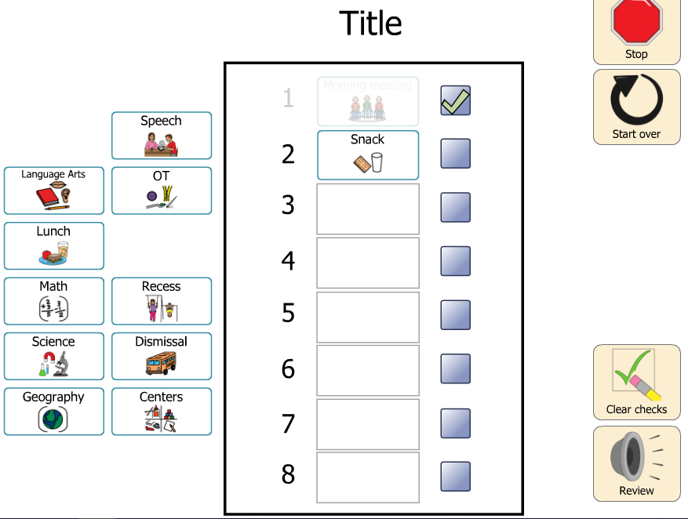

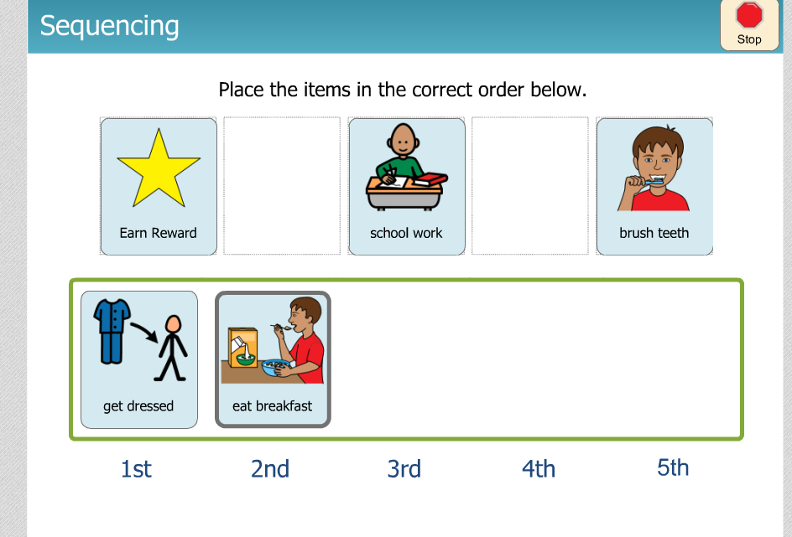

- Boardmaker Online Templates
  - Interactive Schedule
  - Sequencing
- Positivity- Solution Tool through ULS- All teachers of students on access points have access, activities can be assigned to students. A webinar is in the process of being scheduled
- Assistive Technology Toolkit in Canvas- Check out the Visual Supports Tab- go to the Visual Support Resource Section
- https://socialexpress.com/ Free access right now
- https://do2learn.com/SocialSkills/overview.htm Explore :-) There is also a behavior management section.
- http://bit.ly/polkelem
  - Choose the behavior on a chart and it will provide you with options to consider
- https://www.pbisworld.com/ Same as above
- http://www.oneplaceforspecialneeds.com/main/library_social_stories.html
  - Social Narratives
- 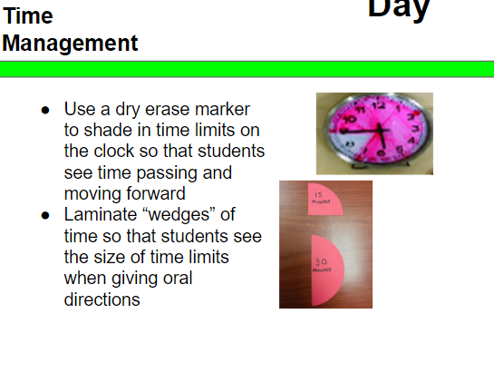
- https://www.socialthinking.com/free-stuff
- https://www.online-stopwatch.com/
- https://classroomscreen.com/

All are great resources- Parents may need help with ideas on how to implement and what to do.

https://docs.google.com/document/d/1lr5E6TVd5ow7ycCqcIIQt1XzLe2zmpFUW87KL8QLnNg/edit?usp=sharing

