Reading Checklist:  ___ I read the entire passage first.  ___ I read the question.  ___ I went back into the text and looked for evidence (underline or circle)  ___ I read all the answer choices and selected the best answer choice.  ___ I tried my best!  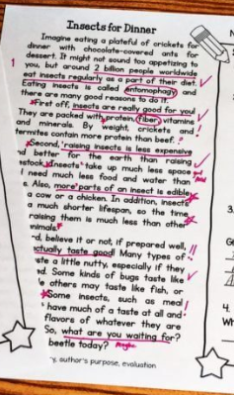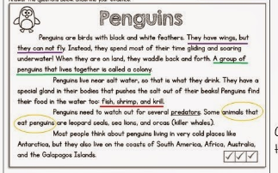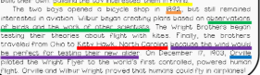 | Math Checklist:  ___ I read the question.  ___ I used a strategy to solve the problem.  ___ I showed my work.  ___ I read all the answer choices and selected the best answer choice/choices.  ___I tried my best!  Showing Work Examples:  